**Summary:**

The GW Research team facilitated data manager meetings this fall with each of the current MNH PRiSMA sites: Pakistan, Ghana, Zambia, and Kenya. The goals of these meetings are to develop and run universal codes to support management of the ReMAPP study. Data reported in this report are from the 14-Dec-2021 meeting. Pilot hemoglobin (Hgb) data was measured by complete blood count (CBC), Hemocue and Masimo devices (**Table 1**). Distribution of measurement methods varied across sites, although all sites had the majority of measurements from either Masimo or Hemocue devices rather than CBC. The patterns of mean Hgb by trimester show slightly higher averages in Trimester 1 compared to Trimester 2 and 3 (**Table 2**). There is a very high burden of anemia in Pakistan and Ghana sites (45% and 54% respectively), while prevalence was 22% for the Kenya site (**Table 3**). Data from Pakistan and Zambia where Masimo and Hemocue were used suggest possible systematic measurement error at lower Hgb levels (**Figure 1)**. Some digit preference or rounding tendencies while recording Hgb values are apparent in the pilot data, and data managers will review with field staff (**Figure 2**).

**Table 1: ANC Hemoglobin by Measurement Method by Site**

|  |  |  |  |  |
| --- | --- | --- | --- | --- |
|  | Pakistan (n=12,582) | Ghana (n=1,287) | Zambia (n=2,249) | Kenya (n=7,364) |
| CBC (Blood draw) | 2,617 (20.8%) | 259 (20.1%) | N/A | 19 (0.3%) |
| SpHB (Masimo) | 9,965 (79.2%) | 66 (5.1%) | 580 (25.8%) | 4,653 (63.2%) |
| Point of Care (Hemocue) | N/A | 962 (74.7%) | 1669 (74.2%) | 2,692 (36.6%) |

**Table 2: ANC Hemoglobin Descriptive Statistics by Site** *(mean (SD), min-max)*

|  |  |  |  |  |
| --- | --- | --- | --- | --- |
|  | Pakistan (n=12,582)a | Ghana (n=1,283)b | Zambia (n=2,249) | Kenya (n=7,364)c |
| Trimester 1 | 11.1 (1.4), 5.0-15.4 | 11.1 (2.1), 5.0-15.8 | 13.2 (1.5), 6.2-17.5 | 12.4 (1.4), 6.4-16.2 |
| Trimester 2 | 11.0 (1.5), 4.6-15.9 | 10.5 (1.7), 4.0-16.0 | 12.4 (1.4), 7.7-16.2 | 11.8 (1.6), 3.7-16.4 |
| Trimester 3 | 11.0 (1.5), 4.2-15.9 | 10.4 (1.6), 5.1-15.8 | 11.9 (1.4), 7.1-16.2 | 11.8 (1.6), 4.0-18.0 |
| Overall | 11.0 (1.4), 4.2-15.9 | 10.4 (1.8), 4.0-16.0 | 12.3 (1.5), 6.2-17.5 | 11.8 (1.6), 3.7-18.0 |

*a 4,476 observations missing gestational age*

*b 105 observations missing gestational age*

*c 239 observations missing gestational age*

**Table 3: Prevalence of Anemia by Site**

|  |  |  |  |  |
| --- | --- | --- | --- | --- |
|  | Pakistan (n=12,582) | Ghana (n=1,287) | Zambia (n=2,249) | Kenya (n=7,364) |
| Anemia, CDC1 *n (%)* | 3,681 (45.4%)a | 645 (54.7%)b | N/A | 1,616 (22.7%)c |
| Anemia, WHO *n (%)* |  |  |  |  |
| Mild Anemia2 | 2,750 (21.9%) | 312 (24.2%) | N/A | 1,105 (15.0%) |
| Moderate Anemia3 | 3,443 (27.4%) | 405 (31.5%) | N/A | 795 (10.8%) |
| Severe Anemia4 | 76 (0.6%) | 21 (1.6%) | N/A | 44 (0.6%) |

*1Hemoglobin < 11g/dL in Trimesters 1 & 3, Hemoglobin <10.5g/dL in Trimester 2*

*2 Hemoglobin 10-11g/dL*

*3 Hemoglobin 7-10g/dL*

*4 Hemoglobin <7g/dL*

*a 4,476 observations missing gestational age*

*b 105 observations missing gestational age*

*c 239 observations missing gestational age*

**Figure 1: Hemoglobin measures by gestational age**

**A. Pakistan B. Ghana**

**C. Zambia D. Kenya**

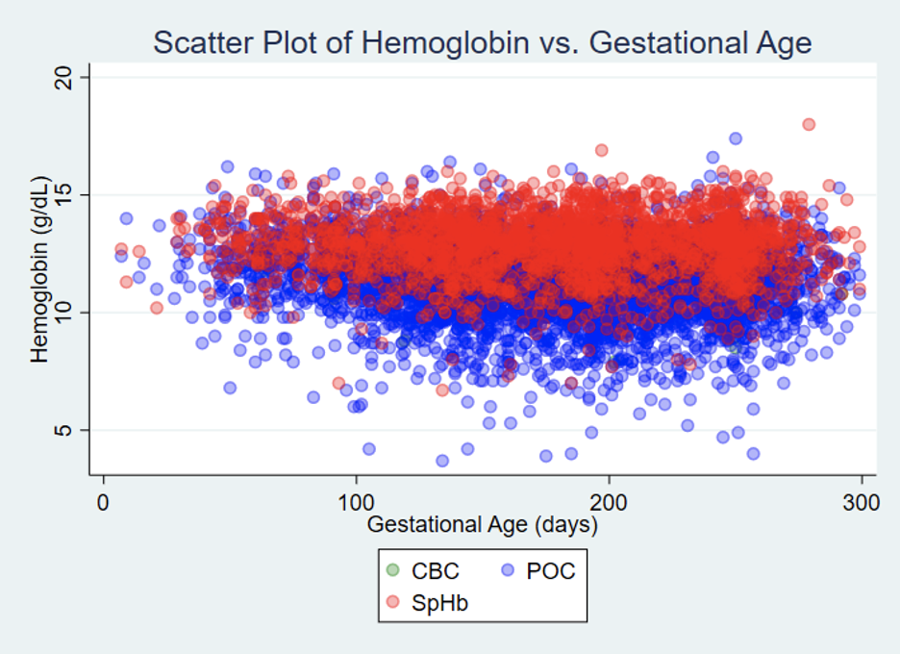

**Figure 2: Hemoglobin values by trimester**

**A. Pakistan B. Ghana**

**

**C. Zambia D. Kenya**

